

CYTOCOPASI

V1.0 User Manual

12 APRIL 2023

SCIENTIFIC COMPUTING RESEARCH UNIT CHEMISTRY DEPARTMENT ROOM 6.37, 6TH LEVEL PD HAHN BUILDING, NORTH LANE UNIVERSITY OF CAPE TOWN RONDEBOSCH, 7701

EMAIL: adminscru@uct.ac.za

Table of Contents

CytoCopasi Cytoscape App 1.0 3

License 4

1- Installation 5

2- CytoCopasi Interface – Panel 7

3- CytoCopasi Interface – Network View 8

3.1- Visual Style 9

3.2- Nodes 9

3.3- Edges 10

3.4- Tables 10

4- Creating a New Model 11

4.1- New Model Dialog 12

4.2- New Compartment Dialog 12

4.3- New Species Dialog 13

4.4- New Reaction Dialog 14

4.4.1 Chemical Equation 14

4.4.2 Rate Law from CytoCopasi’s Function Database 15

4.4.3 Rate Law - Custom 15

4.4.4 Parameter Query via BRENDA 16

5- Saving Models 18

6- Importing a Model – KEGG Networks 18

6.1- KEGG Subnetwork Extraction 19

7- Editing Model Elements 20

8- Simulation Tasks 21

8.1- Time Course Simulation 21

8.2- Steady-State Analysis 23

8.3- Comparative Simulation Analysis 23

8.4- Parameter Perturbations on the Same Model 26

9- References 31

CYTOCOPASI MANUAL

# CytoCopasi Cytoscape App 1.0

CytoCopasi is a Cytoscape [1] app that enables modeling, importing, simulating, and comparing biochemical reaction networks. It uses the Java bindings of Complex Pathway Simulator (COPASI)[2] for quantitative systems biology modeling.

Besides the regular ODE-based tasks, such as time course simulation and steady state analysis, users can also superimpose and compare two chemical reaction networks (e.g., a healthy vs diseased state) to display the concentration deviations. Users can also manually perturb a model by modifying one or more parameters of their choice (e.g., the activity of an enzyme or the initial concentration of a drug molecule) and visualize the downstream effects on simulated concentration profile.

**Features:**

* Systems Biology Markup Language (SBML)[3] support
* Ability to import local SBML files
* Direct connection to Kyoto Encyclopedia of Genes and Genomes (KEGG)[4] for importing pathways and converting them into SBML
* Ability to extract KEGG modules as subnetworks
* Supports BRaunschweig ENzyme Database (BRENDA)’s [5] SOAP access for enzyme functional data queries
* Comparative systems biology analysis to visualize deviations between two reaction networks
* Perturbation analysis to visualize downstream effects of mutations or drug treatment
* Optional dynamic simulation via SBMLSimulator[6]

# License

The GNU General Public License is a free, copyleft license for software and other kinds of works.

The licenses for most software and other practical works are designed to take away your freedom to share and change the works. By contrast, the GNU General Public License is intended to guarantee your freedom to share and change all versions of a program--to make sure it remains free software for all its users. We, the Free Software Foundation, use the GNU General Public License for most of our software; it applies also to any other work released this way by its authors. You can apply it to your programs, too.

When we speak of free software, we are referring to freedom, not price. Our General Public Licenses are designed to make sure that you have the freedom to distribute copies of free software (and charge for them if you wish), that you receive source code or can get it if you want it, that you can change the software or use pieces of it in new free programs, and that you know you can do these things.

To protect your rights, we need to prevent others from denying you these rights or asking you to surrender the rights. Therefore, you have certain responsibilities if you distribute copies of the software, or if you modify it: responsibilities to respect the freedom of others.

For example, if you distribute copies of such a program, whether gratis or for a fee, you must pass on to the recipients the same freedoms that you received. You must make sure that they, too, receive or can get the source code. And you must show them these terms so they know their rights.

Developers that use the GNU GPL protect your rights with two steps: (1) assert copyright on the software, and (2) offer you this License giving you legal permission to copy, distribute and/or modify it.

For the developers' and authors' protection, the GPL clearly explains that there is no warranty for this free software. For both users' and authors' sake, the GPL requires that modified versions be marked as changed, so that their problems will not be attributed erroneously to authors of previous versions.

Some devices are designed to deny users access to install or run modified versions of the software inside them, although the manufacturer can do so. This is fundamentally incompatible with the aim of protecting users' freedom to change the software. The systematic pattern of such abuse occurs in the area of products for individuals to use, which is precisely where it is most unacceptable. Therefore, we have designed this version of the GPL to prohibit the practice for those products. If such problems arise substantially in other domains, we stand ready to extend this provision to those domains in future versions of the GPL, as needed to protect the freedom of users.

Finally, every program is threatened constantly by software patents. States should not allow patents to restrict development and use of software on general-purpose computers, but in those that do, we wish to avoid the special danger that patents applied to a free program could make it effectively proprietary. To prevent this, the GPL assures that patents cannot be used to render the program non-free.

# Installation

#### System Requirements

* Windows, Linux, Unix, or MacOS operating system
* Cytoscape 3.8. or above <https://cytoscape.org/>
* Java OpenJDK 11.0.14 or above

#### IMPORTANT: Native Libraries

**The CytoCopasi JAR file contains native library files, .dll, jnilib, and .so for Windows, MacOS, and Linux/Unix, respectively.**

**The recent version of CytoCopasi can load these libraries automatically; however, should Cytoscape throw an “Unsatisfied Link Error”, you can also try to manually copy the appropriate native file to a directory in your java.library.path** **and restart Cytoscape.**

**How to see the current value of the java.library.path variable**

Java.library.path usually contains multiple directories, but the user can copy the native library to any of them. For all OS types: Open Terminal and type

java -XshowSettings:properties

(find the java.library.path section in the output)

**To Copy the Native Library to Your java.library.path:**

* Download the CytoCopasi-1.0.jar from the release section of the repository <https://github.com/scientificomputing/CytoCopasi>
* Download the additional files as a .zip and extract the folder, which will be named CytoCopasi-main

**Mac OS X**

* Go to CytoCopasi-main/Native Libraries/

The correct type of Mac OS X native library depends on your Mac processor. If you are not sure, this [article](https://www.makeuseof.com/how-to-find-out-if-your-mac-uses-intel-or-apple-silicon/) explains how to find out

* For intel (x64): go to Mac OS X (Intel)
* For M1/M2 chips: go to Mac OS X M1M2
* Open terminal
* sudo cp libCopasiJava.jnilib <the selected java.library.path directory>
  + ex: sudo cp libCopasiJava.jnilib /Library/Java/Extensions
* Enter your user password when prompted.

**Windows:**

* Go to CytoCopasi-main/Native Libraries/Windows
* Run terminal (Windows PowerShell) as administrator (this option will appear when you right-click on the terminal icon.
* cp CopasiJava.dll <the selected java.library.path directory>

**Linux/Unix**

* Go to CytoCopasi-main/Native Libraries/Linux
* Open terminal
* sudo cp libCopasiJava.so <selected java.library.path directory>

#### Installation

Since CytoCopasi is not yet available on App Store, you need to install it in one of the following two methods.

1. **App Manager**

Click on “Install from file” on the App Manager Dialog, and find the downloaded

.jar file

1. **Copy the downloaded jar file**

Copy the jar file to [...]/CytoscapeConfiguration/3/apps/installed

Once the installation is complete, you will see the CytoCopasi tab on the left panel space (see Figure 1).

# 2- CytoCopasi Interface – Panel

This section includes an overview of the CytoCopasi panel components.

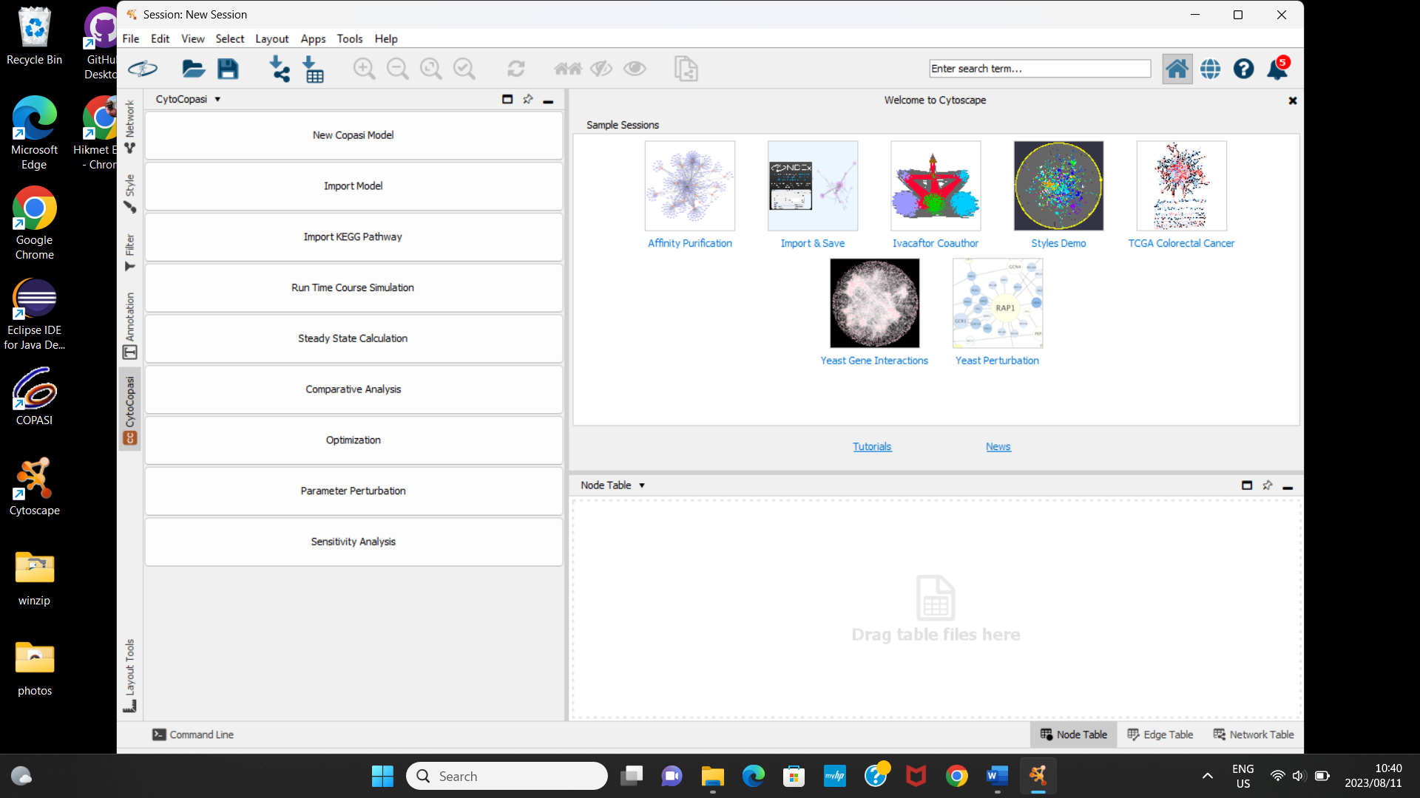

*Figure 1: CytoCopasi Panel*

**New Copasi Model:** Click this button to start manually curating a new COPASI model.

**Import Model:** Import an SBML (.xml) or COPASI (.cps) file

**Import Model From KEGG:** This button brings up a dialog to select a KEGG pathway to download, convert to SBML, and import.

**Time Course Simulation:** Run a deterministic time course simulation on a new or imported model.

**Steady State Analysis:** Determine steady-state in new or imported models

**Optimization:** Minimize an objective function by scanning one or more parameters over a given range.

**Parameter Perturbations:** Run multiple simulations over a range of parameters to determine the dependence of a model value on the parameter.

**Sensitivity Analysis:** Measures how much a sensitive a specific model value (e.g., steady state concentrations or fluxes) to kinetic parameters.

# 3- CytoCopasi Interface – Network View

This section includes an overview of the CytoCopasi Network View Elements



*Figure 2: CytoCopasi Network View - Metabolites are represented with circular nodes, and reactions are represented with square nodes.*

# 3.1- Visual Style

CytoCopasi offers two visual styles, Cy3Copasi and Cy3Sbml[7], for .cps and

.sbml files, respectively. These style files are located in

…/CytoscapeConfiguration/app-data/CytoCopasi/styles.

The appropriate visual style will appear in Cytoscape’s Style tab when the user creates or imports a model.

You can view and customize the style attributes (e.g., node shape, edge color, arrow type) from the properties section of the Style tab.

# 3.2- Nodes

There are two types of nodes in a CytoCopasi model. The circular nodes represent species, or metabolites, while smaller and square-shaped nodes represent reactions. Reaction node colors indicate reversibility of a reaction, where blue means reversible and red means irreversible.

We have chosen to implement node representations for reactions instead of arrows (edges) – only to make the reaction display more meaningful and representative of enzyme-catalyzed reactions.

Users can double-click on the nodes to view and modify the details of these model elements.

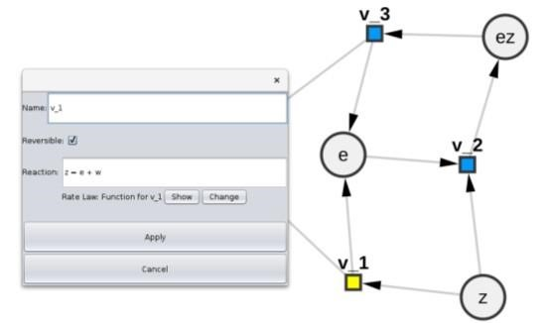 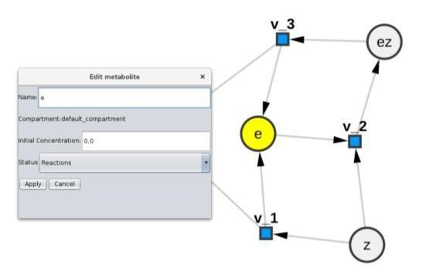

*Figure 3: Dialogs for Viewing and Editing Metabolite and Reaction Specifics*

Finally, users can modify node size, color, and shape from Cytoscape’s Style tab.

## 3.3- Edges

Edges represent the direction of the reaction network. Each species node will be connected to at least one reaction node. Arrows indicate inputs and outputs of the reaction.

The edge will have a single arrow if the reaction is irreversible and a double arrow if it is reversible.

For reactions with inhibitors, the inhibition is depicted with the inhibitor connecting to the reaction node with a T-shaped red dashed arrow.

Users can modify edge style attributes from the Properties section in the Styles tab.

## 3.4- Tables

Node, edge, network tables allow users to overview and change model values.

Node table show summarizes the features of species and reactions.

For species, user can view the following:

* Shared name
* Name: Species
* Type
* Id: Unique ID number assigned by COPASI
* CN: Common Name format assigned by COPASI
* Display Name (usually the same as name and shared name)
* Compartment: The compartment that the species is located in. It will be *default* if the user has not specified it or if it was not specified in the imported model.
* Initial concentration: Species concentration before the simulation. If not specified, it will be 1.0 (units) by default, which the user can change later on.
* Status:
  + Reactions: the concentration/amount of the species is determined by the kinetic laws of the reactions that modify the species (this is the default unless explicitly specified)
  + Fixed: the concentration/amount of the species has a constant value

(which corresponds to the given initial value) o Assignment: the concentration/amount of the species is determined by evaluating the given mathematical expression

* + ODE: the rate of change of the species concentration/amount is determined by an ordinary differential equation

For reactions, the node table contains the following columns:

* Shared name
* Name
* Type: Reaction rev (reversible) or reaction irrev (irreversible)
* Id: Unique ID number assigned by COPASI
* CN: Common Name format assigned by COPASI
* Display Name (usually the same as name and shared name)
* Reversible (box checked if so, blank otherwise)
* Chemical equation
* Rate law: name of the rate law (whether from COPASI’s function database or user-defined)
* Substrates (list of substrates, separated by comma)
* Substrate units
* Products (list of products, separated by comma)
* Product units
* Modifiers (list of inhibitors, separated by comma)
* Modifier units
* Parameter (list of parameters included in the rate law formula) The edge table summarizes reaction type (reversible, irreversible) or if the substrate connecting to the reaction node is an inhibitor.

# 4- Creating a New Model

This section summarizes the steps of creating a new model and the type of input expected from the user.

## 4.1- New Model Dialog

Clicking on the New COPASI Model button reveals a dialog for specifying the general features of the model.

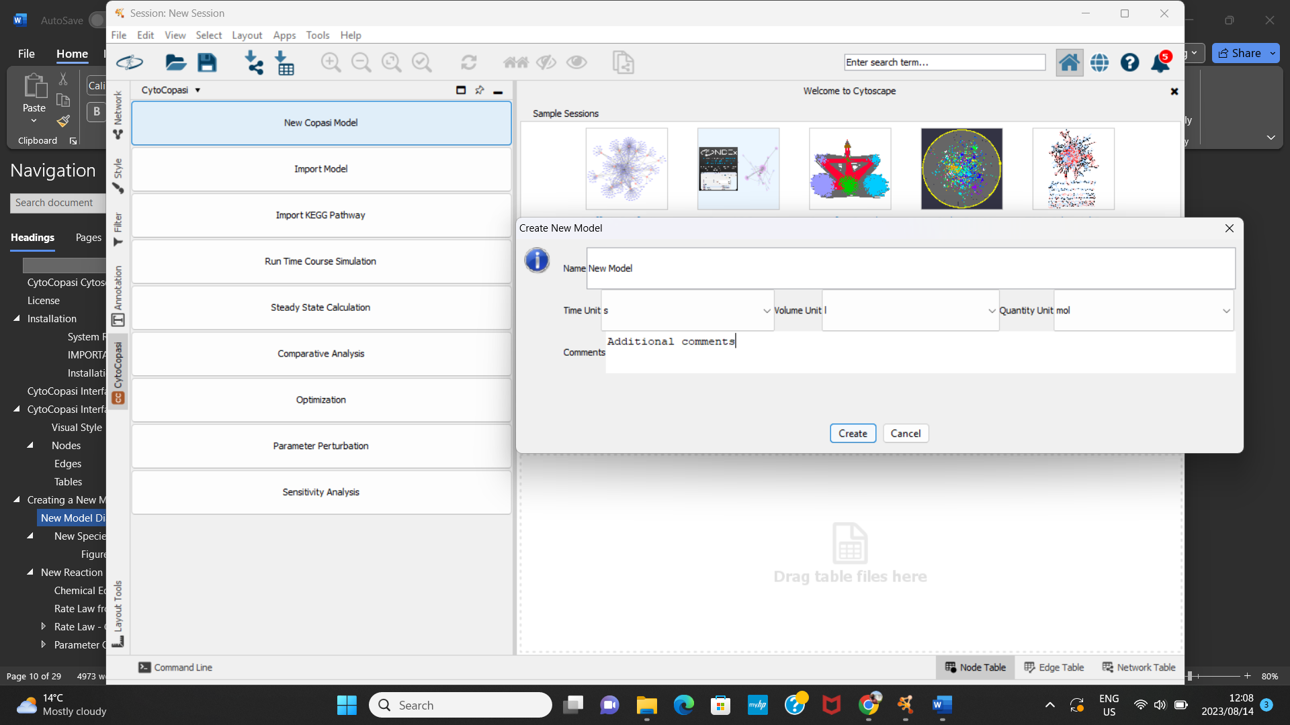

***Figure 4: The Initial Dialog for Creating a Model***

Name: The name of the model

Units: The units assigned here will be applied to the entirety of the model (i.e., concentrations, fluxes, parameters).

Volume: Compartment volume in the volume units the user has specified. Here, the assumption is that the compartment volume is fixed. Future releases will support compartment volume expression in cases where the compartment can expand or shrink depending on concentration changes.

Comments: Cross-reference to literature, other comments you might want to notify the other users about the model.

Clicking on *Create* creates an empty model and a corresponding empty Cytoscape network.

The CytoCopasi panel now displays new buttons that enable users to populate the model.

## 4.2- New Compartment Dialog

Similar to COPASI, species are contained in compartments. The user has the option to define compartments by clicking on “Add New Compartment”.

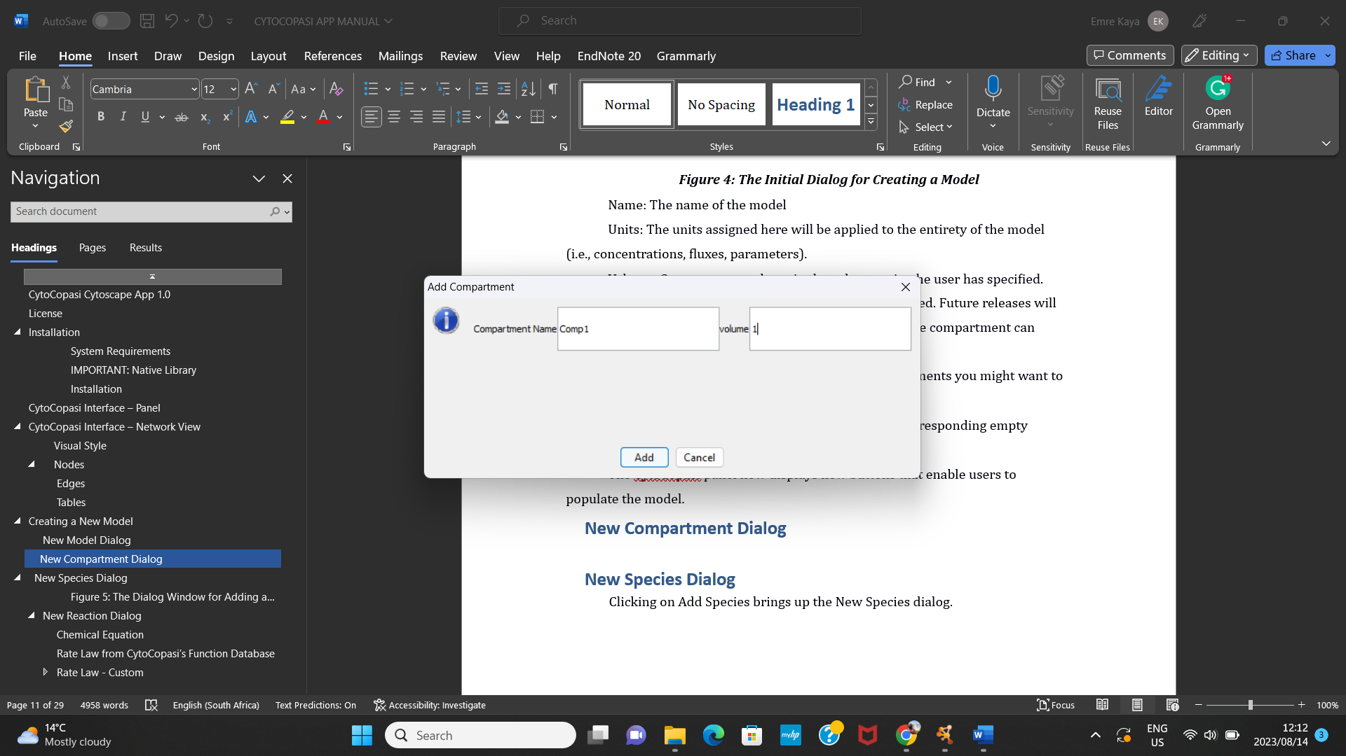

Figure 5: New Compartment Dialog

Note: It is possible to start creating new species or reactions without this step. In that case, CytoCopasi will create a default compartment with a volume of 1 unit.

## 4.3- New Species Dialog

Clicking on Add Species brings up the New Species dialog.

Figure 6: The Dialog Window for Adding a New Metabolite

Name: Name of the metabolite (e.g., Glucose, ATP, C3H7NO)

Initial Concentration: The species concentration before the simulation is run on the model.

Status: Determines how the concentration varies.

* Reactions: the concentration/amount of the species is determined by the kinetic laws of the reactions that modify the species (this is the default unless explicitly specified) o Fixed: the concentration/amount of the species has a constant value (which corresponds to the given initial value) o Assignment: the concentration/amount of the species is determined by evaluating the given mathematical expression
* ODE: the rate of change of the species concentration/amount is determined by an ordinary differential equation

## 4.4- New Reaction Dialog

After creating your model, click on the “Add Reaction” button at the bottom of the panel.

Creating a new reaction in CytoCopasi generates one node for each reactant, one reaction node, and one node for each product, followed by the edges to connect the nodes.

You need to define the name of the reaction, its formula, rate law, and corresponding parameter values.

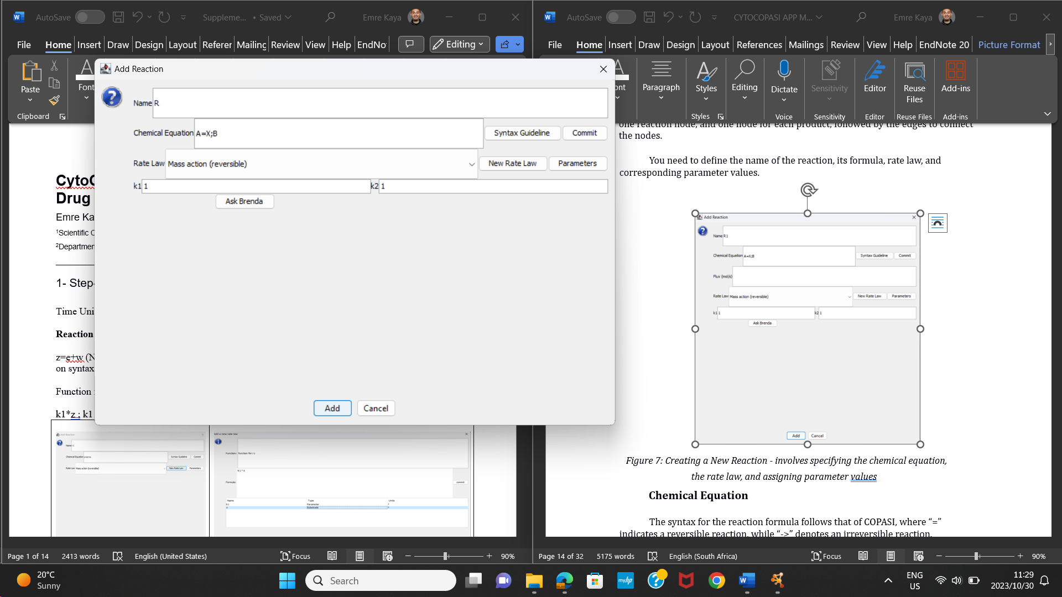

*Figure 7: Creating a New Reaction - involves specifying the chemical equation, the rate law, and assigning parameter values*

### 4.4.1 Chemical Equation

The syntax for the reaction formula follows that of COPASI, where “=” indicates a reversible reaction, while “->” denotes an irreversible reaction. Furthermore, if the reaction rate is affected by a modifier metabolite (e.g., an inhibitor), you need to type it following a “;” sign. For instance, the transition of A to X, inhibited by the metabolite B, would be written as follows:

A=X;B

We put a quick Syntax guideline in reaction dialogs, which you can access by clicking on the Syntax Guideline button next to the Chemical Equation area.

### 4.4.2 Rate Law from CytoCopasi’s Function Database

Click on “Commit” to register the chemical equation. This will prompt CytoCopasi to create a list of rate law functions based on the number of reactants, products, and inhibitors. The rate law formulas for these functions are predetermined, so all you need to do is click on “Parameters” to specify the parameter values.

### 4.4.3 Rate Law - Custom

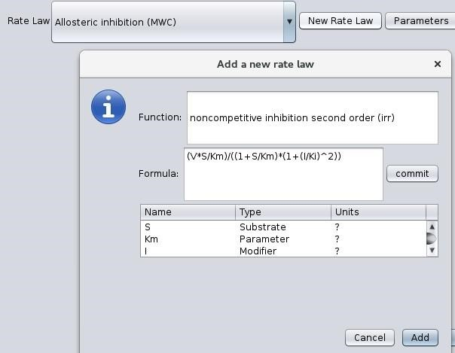

Figure 8: Defining a Custom Rate Law - after committing the rate law formula, you need to assign variables to one of the four types of model entitites: Substrate, Product, Modifier, Parameter

In addition to the function database, CytoCopasi offers the option to assign a custom rate law. Click on “New Rate Law” to open a pop-up dialog, where you can type the formula for your rate law. Click on “Commit” to register the formula.

Next, you need to assign roles to the variables in the formula. By default, each element of the formula has a variable role. You need to specify one of the following roles for each variable: Substrate, Product, Parameter, and Modifier.

### 4.4.4 Parameter Query via BRENDA

We often rely on online pathway and enzyme kinetics databases to construct meaningful systems biology models. Through Simple Object Access Protocol (SOAP), CytoCOPASI provides rapid access to BRENDA, a comprehensive enzyme functional database, allowing you to make rapid queries about organism-specific parameters, such as Km, Ki, and Kcat. You can also view the experimental conditions, such as pH and temperature, under which the kinetics experiments were performed.

Before you can use this feature, you need to register and create an account on BRENDA’s website. It is zero-cost.

On the reaction dialog, you need to click on “Parameters” to enable the “Ask BRENDA” button, which appears under the parameter fields.

Enter your login details to sign in. This might take a few seconds.

In the next window, enter the name of the enzyme you want to find parameters for. Select the organism from the dropdown list. Then, specify the parameter you are interested in (Km, Ki, or Kcat). Click “Search”; the query may take a few seconds.

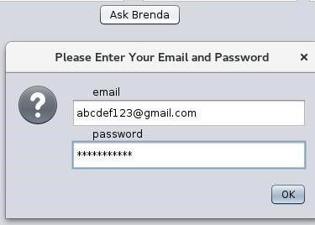

Figure 9: BRENDA Login Window

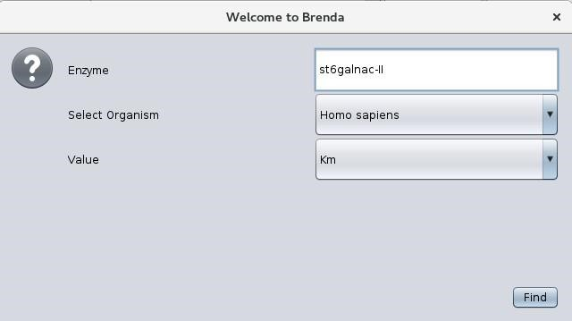

Figure 10: BRENDA Enzyme Query

In BRENDA, enzymes are grouped and stored according to their enzyme commission numbers; however, the same enzyme name can be associated with multiple EC numbers. CytoCOPASI obtains a list of all EC numbers matching your query. You can select the appropriate enzyme based on the full name and synonyms.

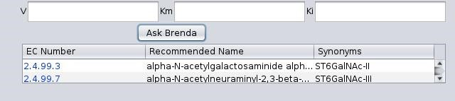

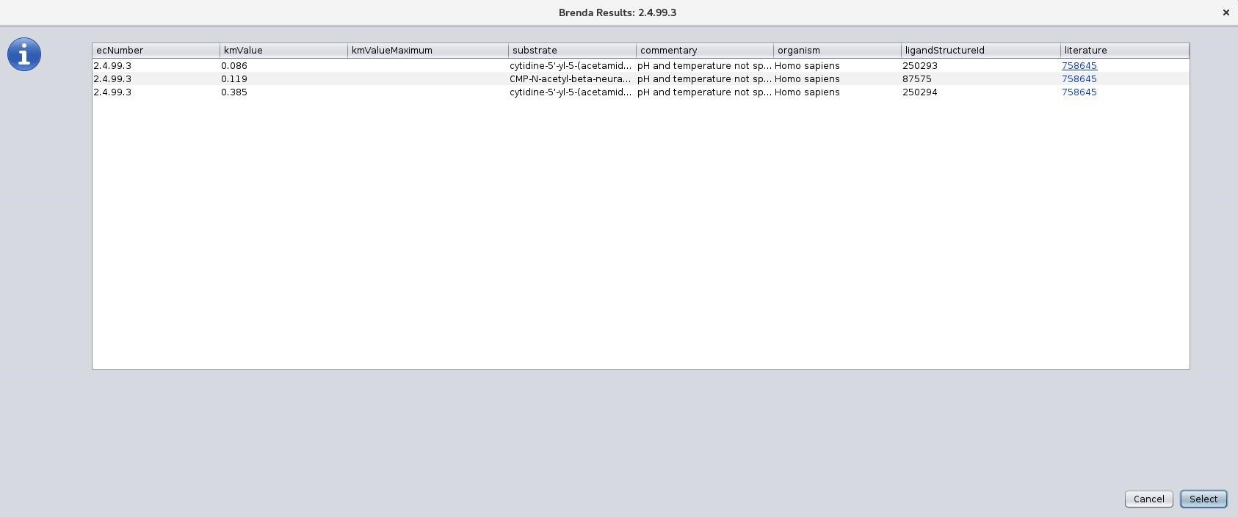

*Figure 11: BRENDA Results - One keyword might return multiple enzymes, so you need to select the appropriate one from the list.*

The results are presented in a table that contains not only the parameter value, but also the range, the substrate, commentary about experimental conditions (e.g., pH and temperature, if specified), substrate structure Id, and the Pubmed reference number hyperlink, which redirects you to the publication for the enzyme kinetics study.

**Note:** You can use the BRENDA search feature on imported models, e.g., when you want to change parameter values or add a new reaction to an existing model.

# 5- Saving Models

You can save your model either as a CPS file by clicking on Save Model or as an SBML file by clicking “Export as an SBML file”.

# 6- Importing a Model – KEGG Networks

You can import CPS and SBML files on your local machine by simply clicking on the “Import Model” button.

CytoCOPASI also supports pathway import from KEGG. Click on “Import Model from KEGG” to bring up the KEGG search bar. You can either manually select the pathway name and organism or type the unique KEGG ID to find the pathway of your interest. Click on “Load” to import the network. CytoCOPASI will download the pathway as a KGML file and use KeggTranslator[8] to convert it to the SBML format. This may take a few seconds.

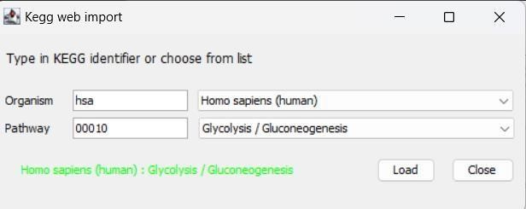

*Figure 12: KEGG Import - Select the organism and pathway name*

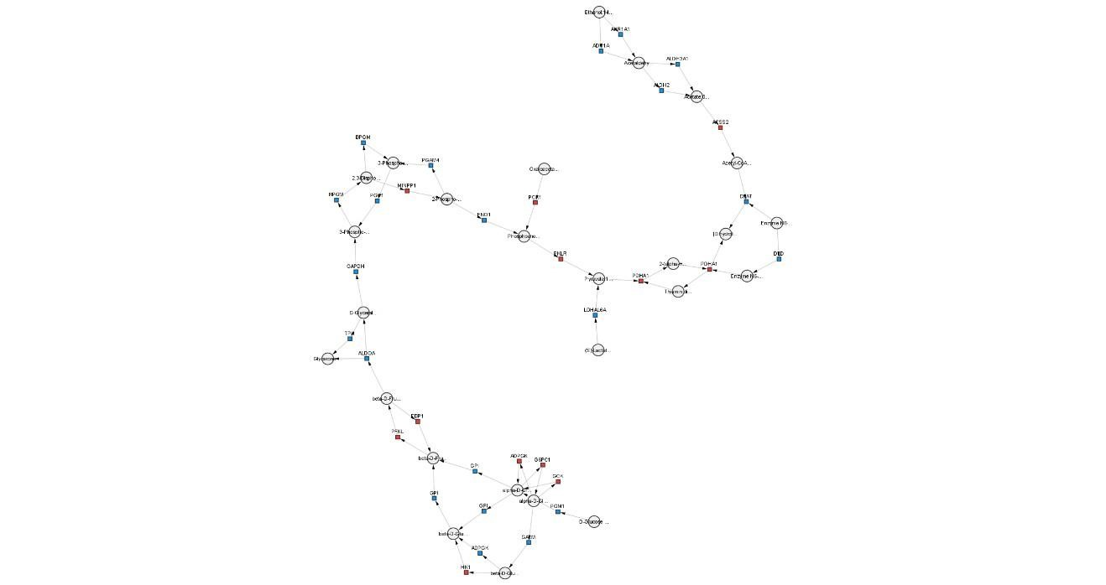

*Figure 13: KEGG Network View - Glycolysis - Glucogenesis*

Once the model is imported, you can add/remove reactions.

## 6.1- KEGG Subnetwork Extraction

Once a KEGG model is imported, a new button “Generate KEGG Subnetwork” will appear on the left panel. This helps isolate parts of the KEGG structure based on the modules of that network.

The list of KEGG modules will appear. Select the module you want to isolate and click “Extract”

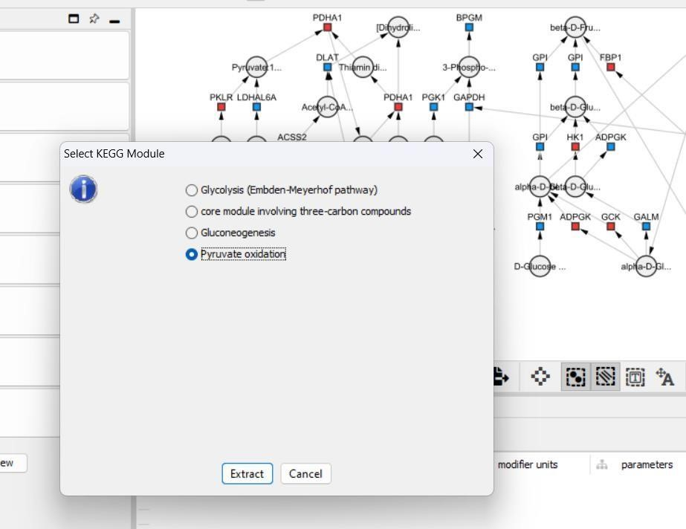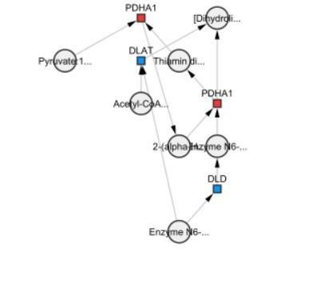

*Figure 14: Extracing The Pyruvate Oxidation Subnetwork from the KEGG Glycolysis Network*

# 7- Editing Model Elements

To view properties of metabolites and reactions, double click on the nodes. Double-clicking on a metabolite node will bring up the metabolite editing dialog, which shows the metabolite name, the compartment it belongs to, initial concentration, and the status (i.e., Fixed, Reaction, Assignment, Time).

Double-clicking on a reaction node will bring up the reaction name, chemical equation, reversibility, and the name of the rate law.

To view the rate law formula, click “Show”.

Click “Edit Reaction” to change the chemical equation and define a new rate law based on that. This means you either add a new metabolite(s) to the reaction of remove one or more metabolites from the reaction (e.g., You want to change A->B to A+ADP ->B+ATP to account for the Adp to Atp conversion). Since the suitable rate laws depend on the number of substrates and products, you need to define the rate law from scratch similar to when creating a new reaction.

Click “Edit Rate Law” to view the parameter values and edit the rate law without changing the chemical equation itself. You can change the rate law by selecting it from the function database, or creating your custom rate law similarly to how you did when creating a reaction from scratch.

You can update parameter values from the table and use BRENDA to look up parameter values.

Click on “Apply” to temporarily save changes to your current model. To save these changes permanently, you need to save the model or export it as an SBML model.

# 8- Simulation Tasks

CytoCopasi supports the simulation tasks found in standalone COPASI.

## 8.1- Time Course Simulation

A time-course simulation task helps users calculate and monitor concentration profiles of metabolites over a given time period.

Running a time-course simulation requires a few parameters:

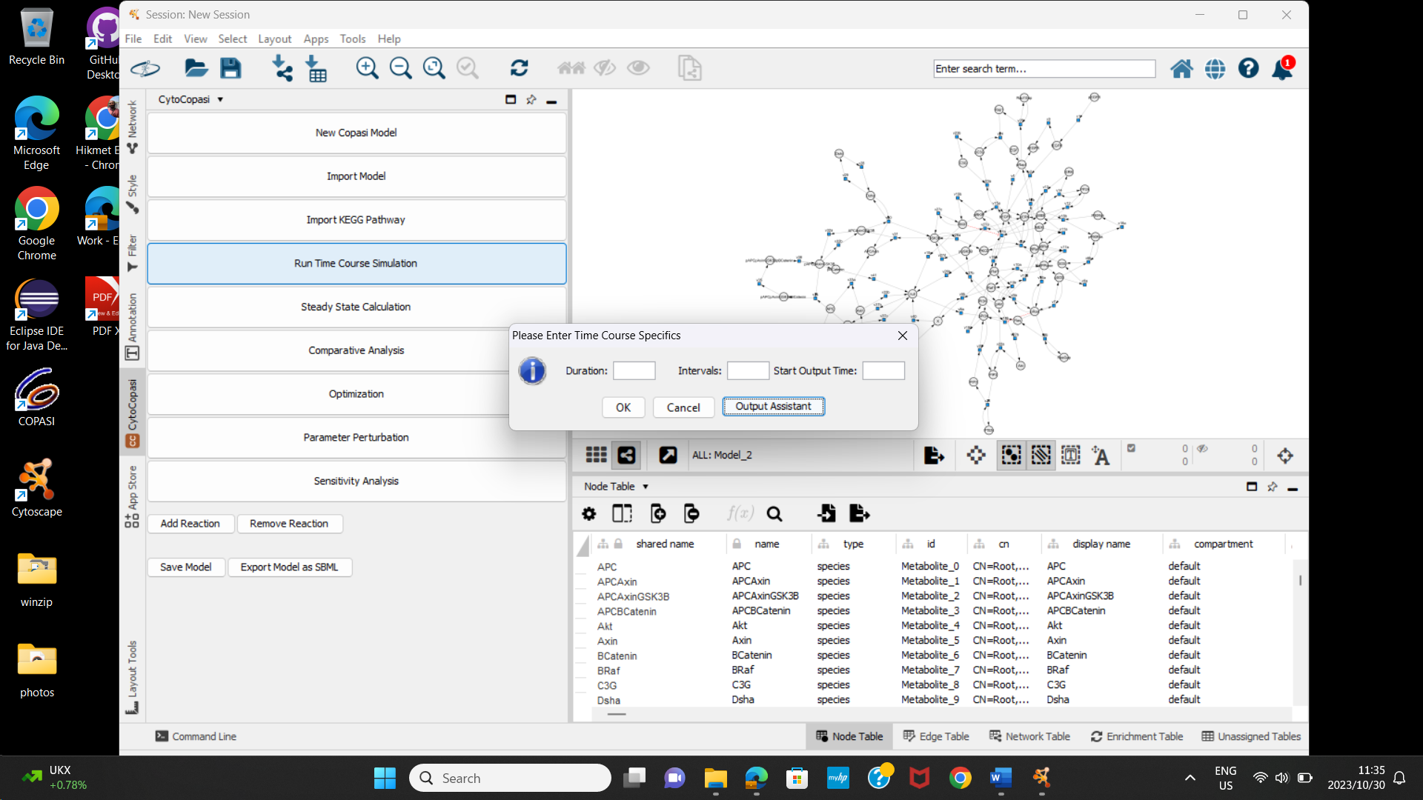

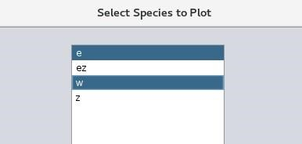

*Figure 15: Time Course Simulation*

*Specifics*

* Duration: The length of the simulation time in time units. For example, if the time unit of your model is in hours, entering “4” means that the simulation will run for 4 hours.
* Intervals: This is the number of checkpoints at which CytoCopasi will take concentration measurements. For example, during a 4h simulation, 100 steps means that concentration will be measured every 0.04 hours or 2.4 minutes.
* Starting time: By default, CytoCopasi will start to track the simulation from t=0, but you can specify a time point such that concentration measurements will begin at that point.

Once these parameters are specified, click on Output Assistant to determine the metabolites you want to plot concentration profiles for. You can select as many metabolites as you like.

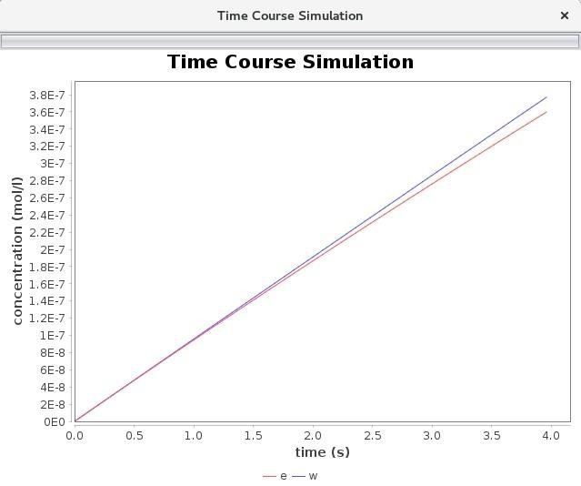

*Figure 16: Time Course Concentration Plot for*

*the Input shown in Fig 15*

CytoCopasi will generate time-course plots on JFreeChart[9], which allows you to customize the plot further.

## 8.2- Steady-State Analysis

Steady-state is the model state, where the concentrations or particle numbers do not change with time. In terms of the ODE-based simulations, steady-state can be defined as the model state, where the differential concentration profiles are all set to zero.

You can run a steady-state analysis on your model from the Steady State Calculation button.

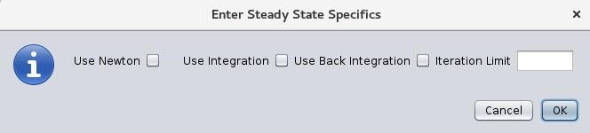

*Figure 17: Steady State Input Dialog*

You can find more details on the steady state calculation methods, such as Newton and Integration on [COPASI’s User Manual. C](https://copasi.org/Support/User_Manual/Methods/Steady_State_Calculation/)heck the appropriate boxes and click OK.

If the model does not reach steady state, CytoCopasi will throw an error message. Otherwise, the model can either reach an equilibrium state, where all fluxes are zero, or a negative state, where the rates of formation and consumption are equal for every metabolite.

In either case, you can view the steady state concentrations, fluxes, and the transition time (the time the model took to reach the steady state) from the first two tabs.

**Insert Steady State Results Table**

The results table consists of the Concentration and Flux tables that display the results, as well as MCA and compare tabs to perform further analysis based on the steady state results.

## 8.3- Comparative Simulation Analysis

You can use comparative analysis to compare a model to its modified version. This is helpful when you want to visualize the alterations (concentrations and fluxes) of a model compared to a perturbed version (e.g., healthy vs disease, disease vs drug treatment. This feature helps you see what metabolites and enzymes are upregulated or downregulated in a disease.

To run comparative analysis, you must click on “Comparative Analysis” on the main CytoCopasi panel.

On the GitHub repository, you will find a series of COPASI files, all derived from the SBML model [BIOMD0000000652.](https://www.ebi.ac.uk/biomodels/BIOMD0000000652)

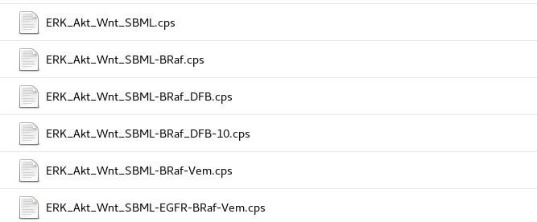

The steps outlined below can be used to display the effects of BRaf mutation on the concentration profile of Padala2017 et al. [10]- ERK, PI3K/Akt, and Wnt signaling network.

* Import the healthy model ERK_Akt_Wnt_SBML.cps
* Import the mutated model ERK_Akt_Wnt_SBML-Braf.cps (formed by deleting reactions 17a and 17b from the first model).
* Select time-course in the “Enter Specifics” dialog, with Duration=15000 and Intervals = 15000
* Run
  + Simulated concentration values of the models will appear in a new column on their respective Cytoscape node tables.

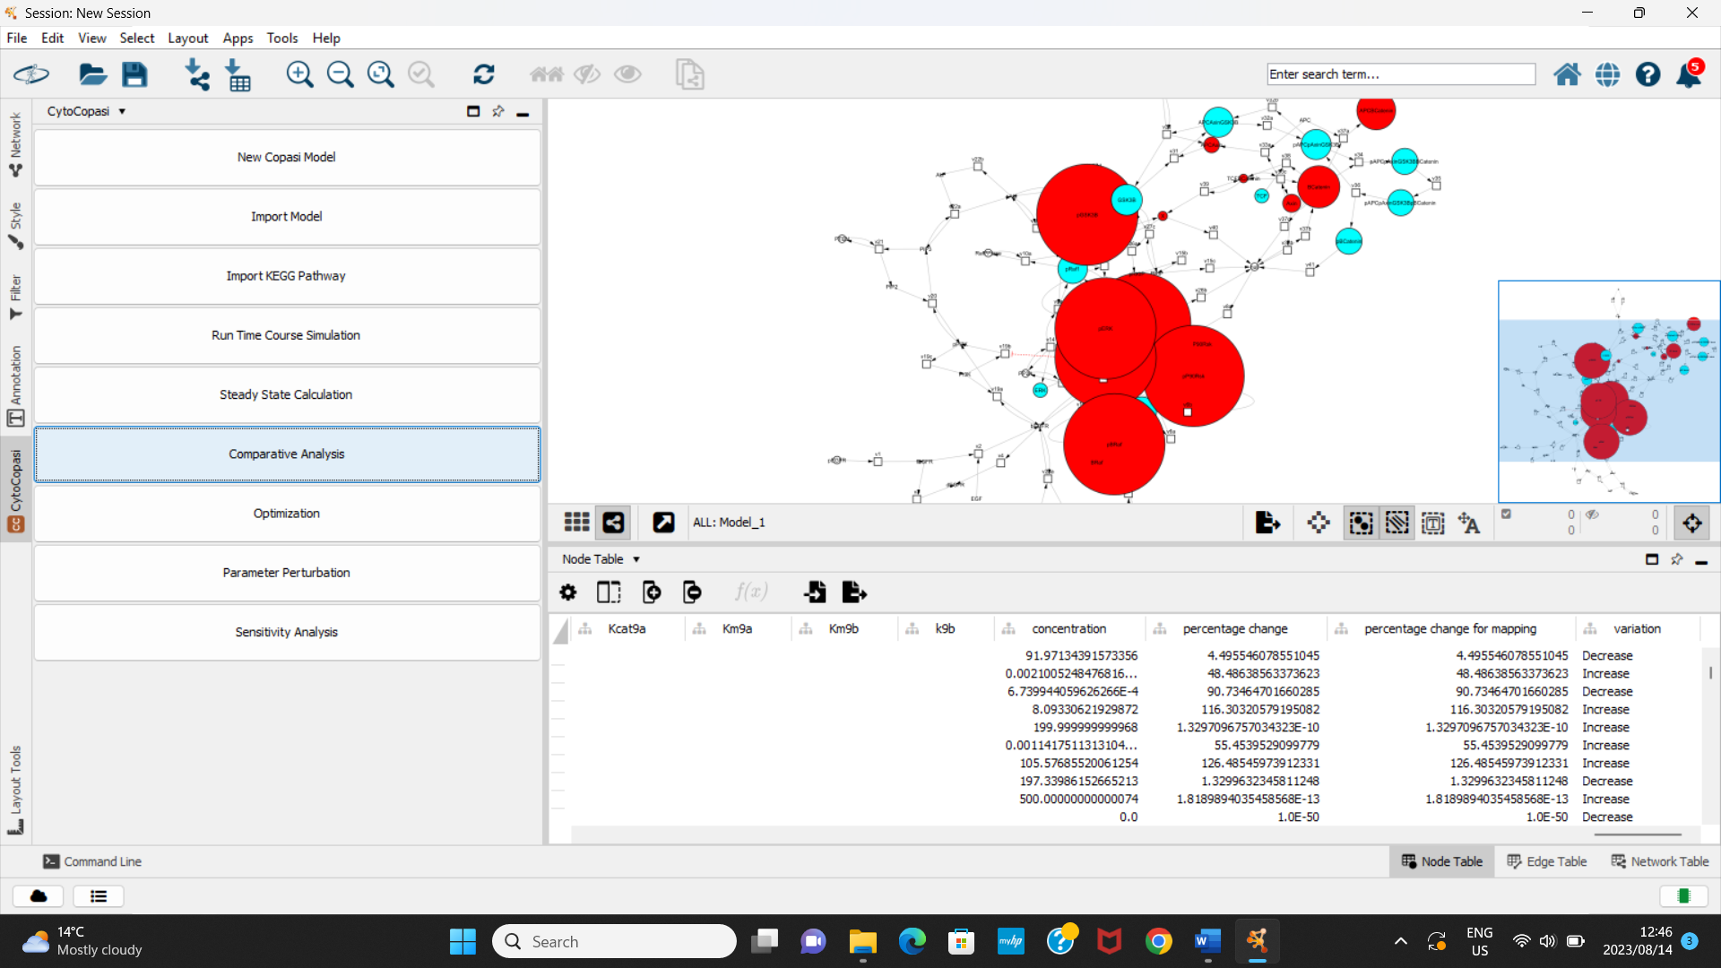

***Figure 18: Concentrations Appear in a New Column***

The BRaf-mutated Cytoscape network will be updated according to the alterations with respect to ERK_Akt_Wnt_SBML.cps. The node sizes of the metabolites or reactions will change depending on the fold change between the simulation results from the two models. The larger the absolute value of the fold change, the bigger the node becomes. Red and Cyan colors indicate upregulation and downregulation, respectively.

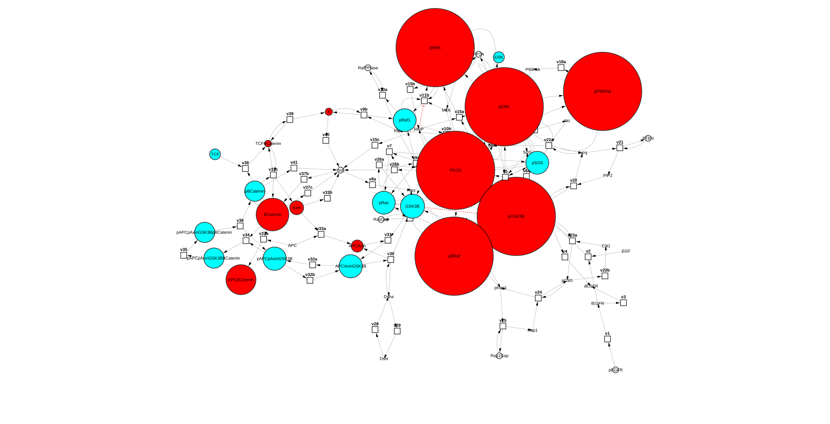

*Figure 19: The Devations in the BRaf-Mutated Signaling Model relative to the Healthy Signaling Model*

To observe the fold changes for each node, simply hover the cursor over them.

The reset button resets the Cytoscape network view, and the nodes become unified in size and color until the next comparison.

If you want to display how Vemurafenib treatment affects the concentration profile of the BRaf-Mutated signaling network, you need to repeat the steps with ERK_Akt_Wnt_SBML-BRaf.cps as the first model and ERK_Akt_Wnt_SBMLBRafVem.cps as the second model.

To find out whether treating the model with Vemurafenib brings the concentration profile back to the healthy values, repeat the steps with

* ERK_Akt_Wnt_SBML.cps as the first model and
* ERK_Akt_Wnt_SBML-BRaf-Vem.cps as the second model.

## 8.4- Parameter Perturbations on the Same Model

CytoCopasi’s parameter perturbation feature runs two sequential ODE simulations on the same model while tweaking one or more parameters of interest. In other words, you can manually perturb the model and display the subsequent impact on simulation results of the same model.

The parameter(s) to tweak include reaction parameters (i.e., enzyme activity) or the initial concentration of a metabolite (e.g., an inhibitor).

### 8.4.1 Single Parameter Perturbation

The example below demonstrates the use of parameter perturbation to display the effect of EGFR overexpression and mutation on the signaling network.

* Import the healthy model ERK_Akt_Wnt_SBML.cps
* Click on Parameter Perturbation from the Panel
* Click on “Add a New Perturbation Item” at the top of the parameter perturbation window.
* Find the reaction v1
  + - pEGFR = fEGFR
    - (This is for the conversion of pro-EGFR to free EGFR)
* Find the parameter V1 and click once
* The initial value is automatically entered as the original value from the model, but you can change it for the simulation to start with a specific value of V1
* Enter 4000 for the final value. This will show what happens to the final concentrations when you increase V1 from 100 to 4000. Click OK

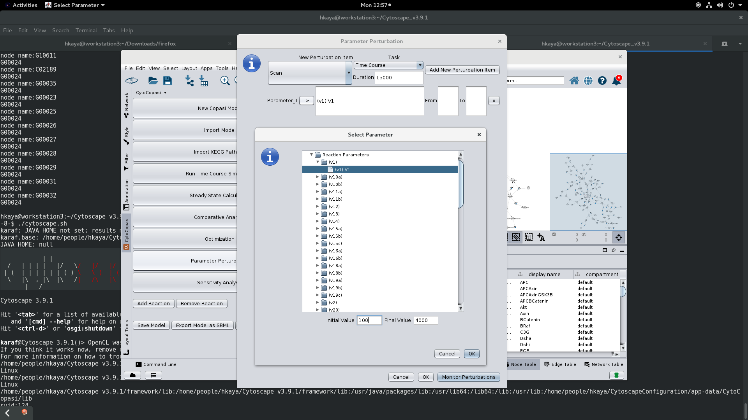

***Figure 20: Parameter Selection - Perturbing the V1 value of the reaction v1***

* Run:
  + The parameter perturbation will prompt the rearrangement of the network.
  + New columns will appear in the node table: Initial Concentration, Final Concentration, Perturbation, and Change%
  + The node size and color is determined by how much the concentration profile is upregulated/downregulated by increasing V1 by 40 folds. (In this case, you won’t see any colors or node growth, which means that the parameter has not perturbed the simulation output significantly.

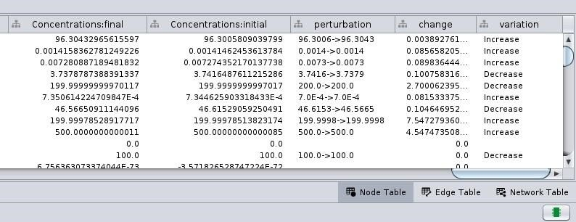

*Figure 21: Perturbation Results - The concentrations before and after the perturbation appear in two separate columns. The fold change is used to readjust node color and size. The bigger the node, the bigger the impact of the perturbation on that node*

### 8.4.2 Multiple Parameter Perturbation

You can run a multiple parameter perturbation, which prompts CytoCopasi to run 2n simulations for n parameters. It will compare the concentration changes between: - the model with the initial values of the parameters and (first simulation) - the model with the final parameter of the parameter (2nth simulation).

The combination of EGFR overexpression and inhibition of EGFR degradation can be demonstrated in this way.

* Follow the single parameter perturbation steps 1-7.
* Click on “Add a perturbation item”
* Find the reaction V4
  + bEGFR = dEGFR
  + B is for bound and d is for degraded
  + V = k4 * [bEGFR]
* Select k4.
* Enter 0.2 for the initial value and 0.005 for the final value

*Figure 22: Perturbation of Multiple Parameters*

* Run:
  + The parameter perturbation will prompt the rearrangement of the network.
  + New columns will appear in the node table: Concentration: Initial, Concentration: Final, Perturbation, and Change%

The node size and color are determined by how much the concentration profile is upregulated/downregulated by changing two parameters. (you will recognize that many cancer hallmarks in the signaling network, such as pERK and pMEK, are upregulated. This shows the significance of Egfr degradation in healthy cell signaling. )

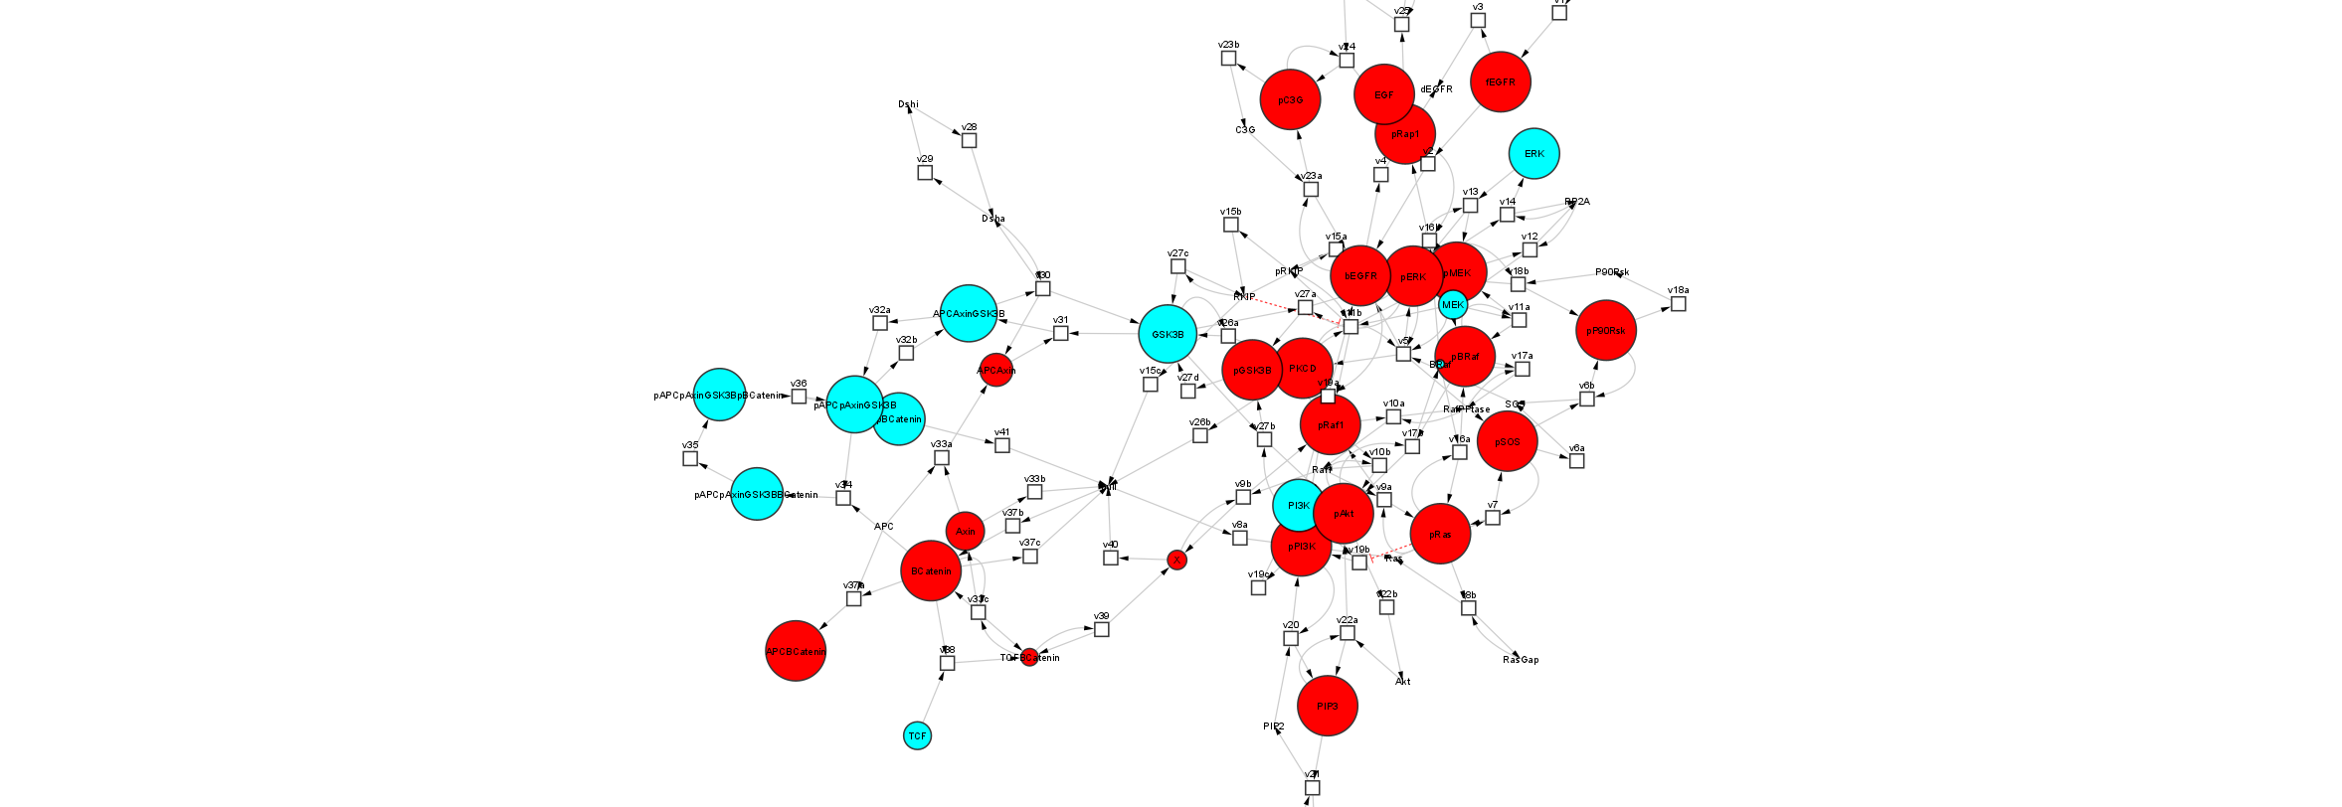

*Figure 23: Impact of Perturbing Two Parameters on the Concentration* Profile

To demonstrate the effect of vemurafenib when a BRaf-mutated network undergoes Egfr mutation, import ERK_Akt_Wnt_SBML-BRaf-EGFR -Vem.cps. This requires a parameter perturbation with three parameters: two from the previous perturbation example, and the third one being the initial Vem concentration (an increase from 0 to 1000 nM).

### 8.4.3- Sequential Perturbation With Consecutive Models

This feature allows the users to connect two sequential systems biology models and investigate perturbations collectively. It may be the case that the user has a set of models, where some of the output metabolites from one model serve as inputs for the next model. Thus, perturbations in the first model could be propagated across these models through the connecting metabolites. CytoCopasi’s sequential perturbation feature aims to help monitor the downstream effects of perturbation in one model across the models that follow it.

This feature is demonstrated with the following example models.

|  |
| --- |
|  |

* muc1-healthy-breast.cps : Healthy glycosylation in breast tissue
* muc1-lumA-breast: Glycosylation in case of Luminal A subtype, formed by changing initial MUC1 concentration and the Vmax values of glycosyltransferases according to the differential expression data from The Cancer Genome Atlas (TCGA). Thus, the time-dependent concentration profiles of the cancerous networks are different from that of the healthy state, and comparison of each cancer version to the healthy state would reveal significant upregulation or downregulation.
* muc1-LumA-breast-Soy: The breast cancer-associated network treated with a drug molecule Soyasaponin I. This molecule acts on the enzyme ST3Gal1, which is responsible for catalyzing the synthesis of a tumor-associated O-glycoprotein MUC1-ST.
* The file monocyte-macrophage.cps represents a reaction network taking place in the monocyte-derived macrophages. The O-glycan epitope MUC1-ST binds and stimulates signaling pathways in the macrophage, yielding CXCL5.
* Finally, the file signaling-breast represents the signaling cascade in the breast tumor cell, where the CXCL5 released by the macrophage binds the tumor cell and activates signaling cascades STAT3, AKT, and ERK. These pathways activate the transcription factor nF-KB, which produces further CXCL5 in the tumor cell, further reinforcing signal activation and CXCL5 production through a positive feedback loop.

These networks are illustrated in Figure 24a, and the metabolites that are common to two consecutive networks are highlighted in red. Thus, the perturbations in the glycosylation network (Fig 24a) will alter the time-dependent concentration of CXCL5 (Fig 24b), which will consequently alter the concentration profiles of the metabolites in the signaling network (Fig 24c)

|  |  |
| --- | --- |
|  | **Systems Model Network** |
| Glycosylation network |  |
| Monocye-Macrophage network |  |
| Signaling network |  |

#### 8.3.4.1 Example 1: Normal vs Luminal A – type Glycosylation

The following workflow describes the investigation of how concentration changes of MUC1-ST between healthy and luminal A manifest in the monocyte-macrophage and intracellular signaling networks.

1. In CytoCopasi, run a comparative simulation by
   1. Importing muc1-healthy-breast.cps
   2. Importing muc1-lumA-breast.cps
   3. Selecting time course and entering 288000 (equal to 80 hours; the time unit for these COPASI models is seconds)
2. The fold changes in transient concentrations between the two models will be displayed on Cytoscape View. A new button appears at the bottom of the CytoCopasi panel: “Add FC as Input to Another Model”

|  |
| --- |
|  |
| *Fig 25: Comparison of transient concentrations between luminal A and healthy glycosylation at t=288000 s* |

1. When you click on this button, a new dialog will appear. First, click on “select the new model to perturb”. Since the metabolite MUCST, which is upregulate in the first comparative simulation, is an input in monocyte-macrophage.cps, select this model for further perturbation. The panel will display the list of metabolites from the new model (monocyte-macrophage.cps).

|  |
| --- |
|  |
| *Fig 26: Sequential Perturbation Panel after selecting the next model* |

1. You need to select the metabolites, for which the initial concentration will be multiplied by the factor of fold change from the previous model. Note that multiple metabolites can be selected. In this case, MUCST at the top of the list is the only metabolite that connects the two models. Select it and click on (+) above the left list. This will add MUCST to the list area on the right.

|  |
| --- |
|  |
| *Fig 27: matching the metabolite from the new model to the one in the old model* |

1. A drop-down list appears under the “to match” column next to the metabolite column. This is to declare which metabolite from the old model the selected metabolite (MUCST) corresponds to. In this case, MUCST is named identically in both models, but there are cases where the same metabolite may be named differently. Note that CytoCopasi metabolite names are case sensitive. Thus, it is necessary make the appropriate selection to declare the connection between the two metabolites. Select MUCST from the drop-down list.
2. There is no need to enter the initial and perturbed values for the initial concentration of MUCST in monocyte-macrophage.cps, as CytoCopasi will take the fold change value from the comparative simulation and use it to determine these values in the backend.
 $Initial:{\left[MUCST\right]}_{0}$

 $Final:{\left[MUCST\right]}_{0}*(1+\frac{PC}{100}*variation)$

 $variation= +/$ 1. − 1 depending on whether the metabolite was upregulated or downregulated. In this case, MUCST was upregulated in luminal A compared to healthy glycosylation, so the initial MUCST concentration must be perturbed in the increasing direction.
3. Enter the duration, 288000 seconds
4. Click on Run

|  |
| --- |
|  |
| *Fig 28: The impact of MUCST (left end) upregulation in luminal A glycosylation (with respect to healthy glycosylation) on the transient concentrations of the Monocyte-derived macrophage model, including CXCL5 (right end)* |

1. To confirm whether the sequential perturbation was performed correctly, you can check the statement on the left under “Model Perturbation”. The fold change indicated for this perturbation must reflect the value under the column “percentage change “ for MUCST in the glycosylation model. You can check this by going back to the previous network through the network tab of Cytoscape.
2. CXCL5 is upregulated (the values of percentage changes can be viewed in the CyTable below the network view.)
3. To investigate the downstream effects of CXCL5 on the metabolites in signaling-breast.cps, repeat steps 2-7.
   1. In step 3, select signaling-breast.cps
   2. In step 4, select CXCL5 and click (+)
   3. In step 5, select CXCL5 from the drop-down list under “to match”
   4. In step 7, enter a custom duration for the new time course simulation. The signaling-breast model has time units of days; here we enter 3.3 days, which is approximately 80 hours (288000 seconds)

|  |
| --- |
|  |
|  |
| *Fig 29: The impact of CXCL5 upregulation due to luminal A glycosylation (with respect to healthy glycosylation) on the transient concentrations of the metabolites in the intracellular signaling network (breast-signaling.cps)* |

Note: The models to be connected do not have to be in the same units, as this CytoCopasi network is concerned with the transfer of fold changes/percentage changes, which are unitless.

#### 8.3.4.2 Example 2: Lum A-type vs Drug-treated Lum A-type Glycosylation

This workflow demonstrates the direct impact of treating the Lum A-type glycosylation network with 0.01 mM Soyasaponin I, an ST3GalI inhibitor, revealing downregulation in MUC1-ST and the downstream monocyte-macrophage and intracellular signaling networks.

1. Import muc1-LumA-breast-Soy.cps
2. Click on Parameter Perturbation
3. Click on “Add a New Perturbation Item” at the top of the parameter perturbation window.
4. Click on the -> button, find Species/Initial Concentration, and select Soy
5. Enter 0 and 0.01 for the initial and final values.
6. Click Ok and Ok on the main window.

|  |
| --- |
|  |

1. Now, you have a percentage change % value for metabolites, including MUCST.
2. You can repeat steps 2-11 from section 8.3.4.1

#### 8.3.4.3 Example 3: Normal vs Drug-treated Luminal A-type Glycosylation

This workflow demonstrates a comparison between normal glycosylation and the drug-treated Lum A-type glycosylation. Here, change in MUC1-ST must be very small between healthy and drug-treated luminal A networks, and no variation will be observed in monocyte-macrophage and intracellular signaling networks.

1. Repeat the steps from 8.3.4.1, but instead of importing muc1-LumA-breast, import muc1-LumA-breast-soy.cps as the second network.

# 9- References

1. Shannon, P., et al., *Cytoscape: a software environment for integrated models of biomolecular interaction networks.* Genome research, 2003. **13**(11): p. 24982504.
2. Hoops, S., et al., *COPASI—a complex pathway simulator.* Bioinformatics, 2006. **22**(24): p. 3067-3074.
3. Hucka, M., et al., *The systems biology markup language (SBML): a medium for representation and exchange of biochemical network models.* Bioinformatics, 2003. **19**(4): p. 524-531.
4. Kanehisa, M. and S. Goto, *KEGG: kyoto encyclopedia of genes and genomes.* Nucleic acids research, 2000. **28**(1): p. 27-30.
5. Schomburg, I., A. Chang, and D. Schomburg, *BRENDA, enzyme data and metabolic information.* Nucleic acids research, 2002. **30**(1): p. 47-49.
6. Dörr, A., et al., *SBMLsimulator: a Java tool for model simulation and parameter estimation in systems biology.* Computation, 2014. **2**(4): p. 246-257.
7. König, M., A. Dräger, and H.-G. Holzhütter, *CySBML: a Cytoscape plugin for SBML.* Bioinformatics, 2012. **28**(18): p. 2402-2403.
8. Wrzodek, C., A. Dräger, and A. Zell, *KEGGtranslator: visualizing and converting the KEGG PATHWAY database to various formats.* Bioinformatics, 2011. **27**(16): p. 2314-2315.
9. Gilbert, D. and T. Morgner, *JFreeChart.* Availab le at [http://www.](http://www/) jfree. org/jfreechart/index. html, 2009.
10. Padala, R.R., et al., *Cancerous perturbations within the ERK, PI3K/Akt, and Wnt/β-catenin signaling network constitutively activate inter-pathway positive feedback loops.* Molecular BioSystems, 2017. **13**(5): p. 830-840.